First Progress Report through end of July:

Foundation Feature Data Extraction

Objective

The objective of this research is to synthesize and develop technology for automated extraction of foundation feature data from imagery. The initial standard for achievement is to decrease human effort by a factor of 10 over current methods in construction of a database. The standard for progress is demonstration of technology that contributes to achieving that goal in a significant way.

This research aims to extract rural roads, rivers, woods and orchards automatically. In previous work supported by NIMA, progress was demonstrated: extraction of pieces of rural roads; extraction of boundaries of uniform regions of water, fields, and clouds; and preliminary evaluation of road detection.

Summary

Thus far, we have made progress in the following stages toward project objectives:

1. Algorithms extract major segments of rural roads automatically over substantial parts of a training subimage. Algorithms link pieces of roads across gaps hierarchically. An algorithm fits circular arcs to broken portions of roads.

2. Road extraction produced roads that are not in the linear feature database, demonstrating the capability for map updating.

3. We have developed an interactive cartography system for development and exploitation of linear features.

4. Algorithms demonstrated multi-spectral ``micro-region'' analysis that extracted regions with small dimensions, on order of a pixel or a few pixels across. Algorithms demonstrated refined discrimination of regions, extracting about 10 classes of imagery regions, e.g. water, construction materials, woods, clouds, shadows, bare fields and several stages of crop growth.

Introduction

The report will be organized to address tasks in the statement of work for the project.

Task 1: Survey of Road Extraction

We made contact with Dr. Martin Fischler of SRI who has had a project under the APGD program of DARPA/ISO. We have determined the technology basis of their effort on road extraction and investigated the status of their work. We presented our current results to Fischler
recently. We plan to analyze and compare results on common data.

We have done a literature search, collected papers, and read those papers on several European efforts on road extraction.

We have not completed gathering information for the survey and have not yet written up an evaluation of the state of the art in road extraction.

Task 2: Extraction of Rural Roads;

Task 2a.a. Evaluate on available data for four sites;

We have worked with one site because data were available for one site only, Santiago de Cuba. For the moment, 20m SPOT 3 band MSI, 30m Landsat 7 band MSI and 5m CIB panchromatic are available. Also, VPF vector data for various linear feature layers and elevation are in hand.

We have algorithms to work with SPOT, Landsat, and CIB imagery, and algorithms to work with VPF road data and presumably other VPF data. We received data for other sites recently. We are not yet able to read all data. We expect to have data for the other sites soon.

Task 2a.b. Develop curvilinear aggregation to form complete unbroken roads;

Figure 1. SPOT Chip 7

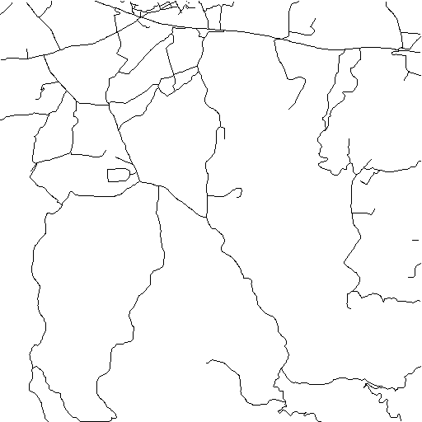
Figure 2. SPOT 7 Map
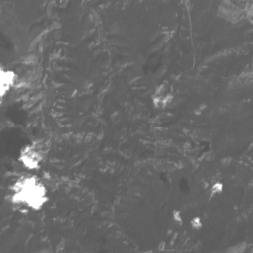
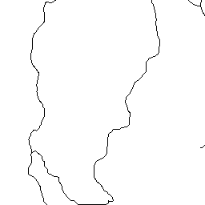

Figure 3. Difficult 1/4 Area from SPOT 7 and its map

A training image subset was chosen to exploit the vector data while reserving a large part of the data for evaluation. (Figure 1) This area is SPOT chip 7, a 10km x 10km area. For SPOT MSI, extended edge segmentation performed as well as previously in 3/4 of the subimage, SPOT chip 7. Extended edge extraction was poor in 1/4 of the image compared to vector data truth. This is the lower left hand portion of Figure 1, which is shown as Figure 3. In this 1/4 of the subimage, humans could not see roads in SPOT imagery, even when the roads were pointed out in detail. This was true for about 10 humans. Also, in this part of SPOT chip 7, humans could not see roads in CIB 5m pan. This area is wooded with low density of roads; about 10% of roads are affected.

The Binford-Chiang edge operator does only as well as humans do who aren't given cues to road location. With cueing, humans do slightly better than the edge operator, but very little better.

In 3/4 of SPOT chip 7 all but lower left, extended edge extraction is reasonably good, as expected, comparable to humans. In that part of the subimage, multi-spectral analysis extracts reasonable areas for construction material. In the problem 1/4 of the subimage lower left quarter, multi-spectral analysis extracts almost no apparent construction material (Figure 3).

A lot of effort went into methods to link road segments in this most difficult part of the image lower left corner. It is not known yet which of several possibilities causes the problem. One possibility is that the road is obscured over several kilometers. A less convincing possibility is that part of the image is degraded in some unspecified way.

It is also not known in what fraction of the full image roads are invisible, hence how much a problem this lack of information is to automation. This area turned out to be different from the two
evaluation areas used previously for road extraction. We intend to compare performance at available resolution of imagery.

The difference from the earlier results is that there were roads in wooded areas in this subimage. The area for which humans and the operator did not perform well is a wooded, hilly area. It was possible to see roads in open terrain in both the green band and in a modified 3 band color image (color histogram equalized). In the areas of difficulty, there was no spectral evidence of the road.

When we examined the same area in CIB imagery, results were slightly better.

Human Discrimination

Some effort was made to verify that limits of human discrimination were fundamental limits, i.e. whether information is present, not limitations of presentation of the images. First, the comparison was done on the same imagery as used by the Binford-Chiang extended edge operator.

Roads were less discriminable in the color image formed by rendering SPOT chip 7 (near-infrared, green, blue) as (red, green, blue). (Figure 4) It was found that color histogram-equalization rendered an image in which roads were much more discriminable; in general, cartographic features were more discriminable. (Figure 5) It was improved by using a demixing process developed at Stanford.

Even in that improved color-rendered image (Figure 6), roads were not discriminable by humans in the 1/4 of the image for which finding roads had been difficult.

Results
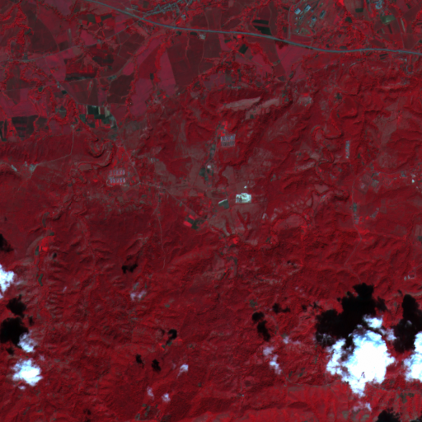

Figure 4. RGB Rendered SPOT7 Pseudo Color Image

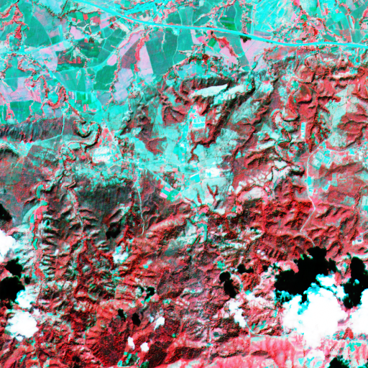

Figure 5. Color Histogram Equalization

Figure 6. Demixing Followed by Color Histogram Equalization

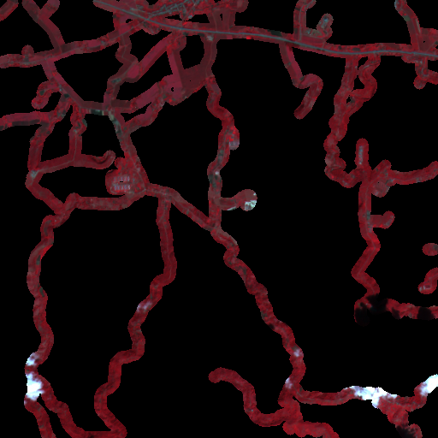

Figure 7. Road Mask

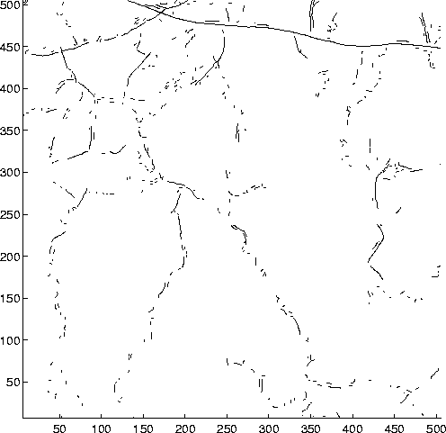

Figure 8. Edges Near Road

Figure 4 shows the SPOT chip 7 subimage as a color image. That subimage appears in figure 5 and 6 histogram equalized and demixed. The roads are cued in figure 7 which shows a mask around each road from VPF data. Detected extended edges for roads are shown in figure 8 in
the masked areas about roads. Performance of the Binford-Chiang operator is perhaps better than one might expect.

Extracting Complete Roads

Our intention is to develop and evaluate road extraction at a range of resolutions of imagery, from 20m SPOT to .1m imagery. When we encountered the difficulty in the lower left corner of SPOT chip 7, we have focused on extracting edges in the difficult area. Then we switched to producing complete linked edges in CIB imagery in typical area.

Linking

After we gave up temporarily on extraordinary efforts to link and extract roads in the worst part of the image, we implemented linking more or less based on the planned algorithm. We worked with 1km x 1km subareas in order to develop intimate familiarity and intuition about individual problems.

Roads are extracted initially as delta edges that are bright, continuous, and extended. Roads are broken by a variety of physical situations for which the roads don't fit that model.
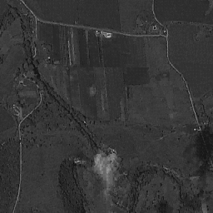
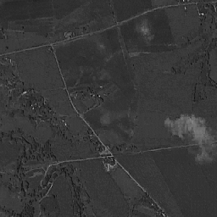

Figure 9. Sample CIB 256 * 256 Area

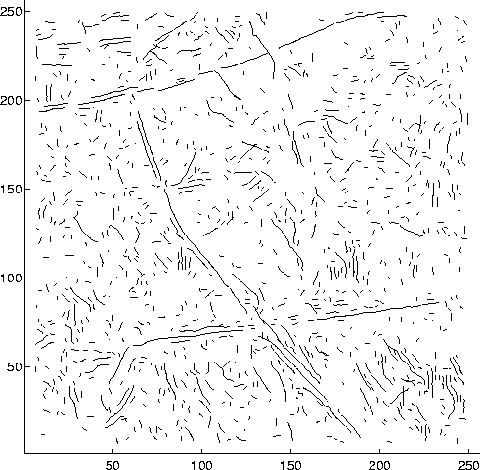
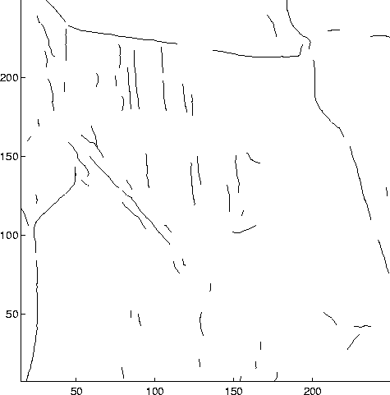

Figure 10. Detected Extended Edges from Sample CIB 256 * 256 Area

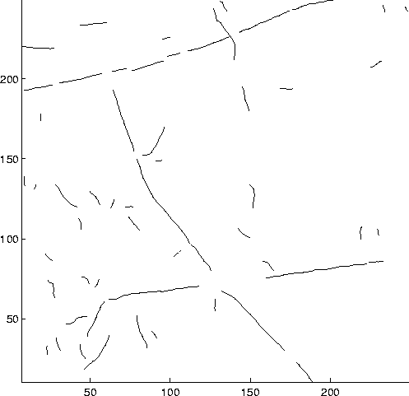

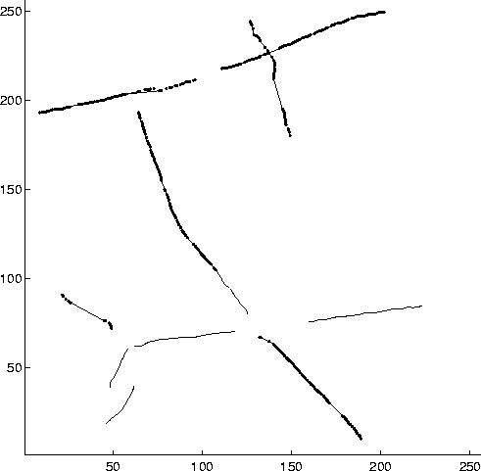
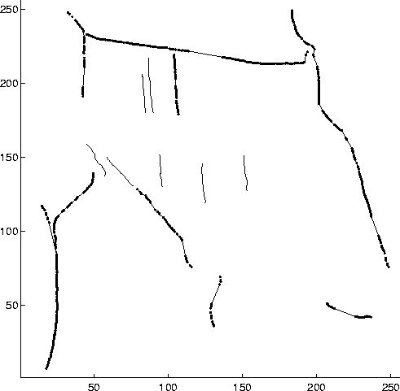
Figure 11. Single Candidate Curves

Figure 12. First Stage Linking Result

For 1km x 1km subareas of SPOT chip 7 using extended edges extracted from CIB 5m imagery, results appear promising. Parameters will be optimized for performance. The method will be extended to large scale to evaluate results.

Analysis is shown for two 1km x 1km subareas shown in Figure 9. About a dozen such subareas have been examined. Figure 10 shows detected extended edges in the two areas. Single candidate curves are selected to favor road segments by selecting segments with minimum length, contrast similar to road segments, and small curvature. Figure 11 shows selected candidate road segments.

Linked pairs of segments are selected by maximum gap, constant curvature, and maximum curvature. Figure 12 shows selected linked segments. Except at junctions, linking is relatively good over 1 km. False alarms are relatively few.

Single curves and linked pairs are to be linked hierarchically by linking at successive stages. The second stage of linking is being implemented. It is intended to bridge breaks at junctions
and larger gaps. To bridge large gaps with low false alarm rates, the false alarm rate of individual segments should be low. Low false alarm rate is achieved by selecting long and strong candidates
from the first stage of linking.

Two linking modules were developed. One linking procedure uses Delaunay triangulation of end points of extended edge segments. The other uses cells in an array to determine proximity.

Linking modules are intended to find neighboring edge segments that are nearby, by comparing only a small fraction of all possible edge pairs. That is, brute force linking could test all pairs of segments. Such an algorithm is at least N^2, where N is the number of extended edges. The linking modules are intended to have low computational complexity by taking account of geometric properties, proximity and continuous tangent. Both modules are successful in this sense. Both have well-defined geometric properties and computational complexity.

Circle Fitting

An algorithm has been developed for fitting circular portions of roads. There was no useful existing circle fit algorithm. This seemed strange, but none worked efficiently with only a small
portion of the circle, none used available evidence, i.e. incorporated constraints of measurement of tangent vector and contrast which are available from the Binford-Chiang operator. Because large parts of roads are smooth and circular, it was useful to use constraints to use the circular constraint to link these sections. Because the Binford-Chiang operator makes accurate measurements, a circular fit would discriminate strongly against linking of non-road segments.

Because large portions of roads are circular and because the Binford-Chiang operator estimates position to subpixel accuracy and orientation to a few degrees, there was reason to believe that circle fitting would provide strong constraints. Avedisian and Binford developed a tangential expression for a circle and found accurate initial estimates for parameters of the circle expression. They found a Newton-Raphson iterative solution that converges very rapidly. (Figure 13)
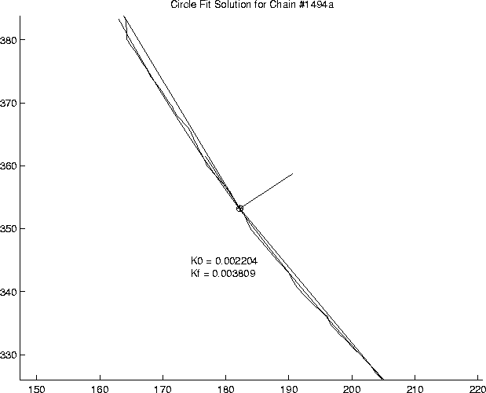

Figure 13. Circle Fitting

Spectral Selection for Road Extraction

We expect roads to be constructed from a few materials, i.e. concrete, asphalt, oil and screen, and unpaved. In road extraction, we would like to use spectral selection to refine selection of roads in order to decrease the false alarm rate or increase probability of detection.

Multi-spectral selection of roads is relatively successful in the 3/4 of SPOT chip 7 in which roads are visible to humans and in which roads are extracted successfully. I.e., in that part of the SPOT chip 7, roads fall in a limited region of the spectrum of SPOT MSI. Multi-spectral selection by itself is not adequate for road extraction in this subimage. Multi-spectral selection can best be regarded as augmenting extended edge extraction. It is expected that multi-spectral selection would not be adequate because roads are about 7m across, while pixels have 20m footprint. De-mixing does improve visibility noticeably for humans and possibly improves detectability for programs, but can not be expected to improve sufficiently to perform road extraction with multi-spectral selection alone or as an initial selection.

With high resolution MSI, at about 2m or so, multi-spectral selection might be adequate to perform initial selection of road candidates.

Multi-spectral selection of candidate road areas was done by sampling some roads manually, analyzing the boundaries of the cluster, then extracting areas with MSI values within the cluster. The procedure was designed to have high probability of detection, about .95. Although there is little human effort involved in designating a few roads for analysis of the cluster, that process could be automated entirely by using those roads that are easily detected initially. Along with roads, multi-spectral selection includes construction areas and buildings. In part of the image, some fields are selected with roads.

Multi-spectral selection is thus successful in the sense that it is a reasonable filter that selects a small part of the total image, perhaps 10%, in the area in which humans see roads.

In the area in which humans do not see roads, multi-spectral selection does not seem successful, in the sense that there are no areas with possible road materials obtained from the other part of the image. Roads are not visible in the multi-spectral data. The only way to maintain probability of detection at 95% here is to accept all spectral values.

A part of multi-spectral selection is incorporated in the current road extraction which selects those extended edges as road candidates which have an amplitude greater than a threshold. The amplitude is estimated by the Binford-Chiang operator.

Map Updating

Several roads were found that are not in the linear feature database of roads. Perhaps these are roads that were not regarded as roads because of some higher knowledge, but they are distinctive features. As time passes, new roads will be built. These data can be used to update road databases.

The current spectral analysis requires cueing of spectral classes by designating several spectral regions. That process could be updated in the future by cueing spectral classes by revisiting regions to use them as spectral signatures for the current imaging conditions.

It is possible that updating of other cartographic features may be more relevant than updating of roads, since other cartographic features undergo more frequent change.

Road Extraction for Difficult Sections

At this point, it is relevant to ask how roads can be extracted in the difficult sections. Since that section has been mapped already, there must be a way. Presumably road extraction was done with better imagery either b/w or MSI in which substantial parts of the road were visible to humans. It is too early to be certain about the status of discriminability and what fraction of terrain is difficult.

A modest increase in detection of road fragments may be enough to make extraction feasible in the most difficult areas. We will build mechanisms to fill in hidden portions of roads from visible portions, guided by elevation contours and road building practice. That use of context depends on finding enough fragments of roads to guide the interpolation process.

It is possible that higher resolution data will eliminate the problem. That has not been the case as we went from 20m to 5m panchromatic. This question seems entirely open now. In particular, higher resolution MSI data might be valuable. However, commercial imagery will be 1m pan and 4m MSI. That might make a dramatic change in effectiveness of automated extraction.

It is possible that different views of an area from different angles have different obscuration. In this case, combinations of multiple looks might show up different parts of roads from different
views. The combination could possibly be sufficient to guide the filling-in process of road completion. Such combination of images may be necessary because of partial perpetual cloud cover over parts of the earth. Combining multiple looks is quite feasible.

Night imagery might show up roads from lights of vehicles. I.e., although rural roads have sparse traffic, motion blur expected from exposure over dwell time would make each vehicle distinguishable. A few looks would give a few samples on the road which go a long way toward making possible a filling-in.

While it is expected that some improvements can be made to the extended edge operator, there does not appear much hope that any operator could do much better than humans who cannot see evidence even where they know the road to be. It is much more promising to get better evidence.

Task 2a.c: develop preliminary Bayesian network:

Work has been done on the design of the Bayesian network and on accumulating conditional probabilities for the Bayesian network. Synthesis and implementation of the Bayesian network has not been done. It was not expected to be done at this point.

Task 2a.d. Develop generic image model

A considerable part of the generic image model has been developed. The purpose of the generic model is to capture knowledge used by cartographers in making cartographic decisions that augment observable evidence. E.g., a road along a lakeside may be only partially visible, partially obscured by forest. A cartographer would reason: form the hypothesis that there is a road along the lake to serve houses there; confirm the hypothesis by connections of road fragments with the road network, by observable road fragments, and by observable buildings; estimate the road path from observable fragments guided by buildings and observable driveways and guided by road construction practice.

Also, in a typical scenario, a road through a hilly, forested area is typically invisible in part and obscured in part by trees. A cartographer can estimate the road's path by using the observable fragments of the road, terrain elevation data, observations about the terrain from photographic evidence, and knowledge of road construction engineering practice.

Those cartographic decisions may not result in accurate completions of substantially incomplete roads, but they improve over our programs abilities of geometric interpolation over short gaps. They provide correct connectivity and roughly correct position of roads, now beyond capability of automated cartography algorithms.

The knowledge that the cartographer uses is encapsulated in a generic model. A generic property in mathematics is a property that holds almost everywhere on a set. The generic model is our knowledge about the world of the area considered, the images of that world, and conclusions that can be drawn from images of the world. The generic model contains a 4D model of objects, a 3D model of volumes, surfaces, curves, and points, and a 2D model of images. The model of objects includes function, intention, and practice demonstrated by the examples above.

The generic model is intended to give an expressive model with high level concepts that are comfortable for cartographers to use to formulate knowledge initially and later incrementally to improve performance of automatic cartography systems. A generic model of interest to us is a model of the road network in general. It is not very useful to model only roads by themselves. It is not enough to model images. Our models above were 3D models. In order to reason from images, it is useful to have generic models of the surroundings of roads, i.e. terrain, buildings and human construction, vegetation, and water.

Individual models are obtained from individual roads, knowledge about them and their images, individual construction areas and their images, individual vegetation areas and their images, etc. Individual models help to supply parameters and their ranges for generic models.

The generic model is likewise intended to be translated into constraints that aid in classification or in hypothesis generation. The Stanford Successor generic model-based system had substantial ability to translate geometric models into Bayesian networks for interpretation. It is our ultimate aim to implement algorithms to translate our generic models and individual models into automated extraction algorithms. For the short-term, our aim is to supply algorithms that help programmers translate generic models into extraction algorithms, that translate incremental additions to generic models into modifications to extraction algorithms.

Thus, our generic model contains models of the road network, human construction, water, terrain, vegetation, and hydrology; it contains a model of image formation for multiple sensors including illumination; it contains a model of extraction algorithms.

The generic model of the road network includes its function: transportation of humans and objects between stationary places at reasonable cost in time and resources; the model includes its implementation: human drivers, vehicles to carry 2-3 people abreast, vehicles with a range of capacity of people (cars, vans, buses) and objects (cars, small trucks, large trucks); roads on the surface with widths that are multiples of a lane, 1, 2, 3, 4, .; roads that are designed for feasible time, i.e. feasible speeds implemented by a number of lanes suited for traffic load with limited curvature, roads that are level (requiring cuts, fill, bridges), that are smooth and durable under traffic loads (constraining materials). Roads traverse terrain by staying as level and straight as possible (a baby form of construction knowledge). Roads connect with other roads to facilitate coverage. Roads terminate at other roads, at human construction, and at water.

That generic model has two levels, the object level and the 3D geometry level. There is another level of the generic model, i.e. the 2D image model. The generic model gives 3D width, materials, curvature and slope. The generic imaging model generates image width, spectral signature, path and curvature. The generic image model includes illumination (the sun and sky), its spectral distribution and geometric properties, sensor spectral response, sensor geometry (frame, pushbroom, orthophoto), image parameters that allow computing angle of sensor rays with respect to a flat earth at each pixel. Some of the necessary information may be lost in an orthophoto.

Task 2a.e. Develop initial learning for road extraction algorithm;

Some work has been done in this direction with Ali and Langley. No substantial progress has been made yet. It was not expected that substantive results or programs would be achieved at this stage.

Task 2f. Develop hypothesis generation based on connectivity, shadows, and material hypotheses.

We are about to implement hypothesis generation of road candidates for extended edges that terminate near strong road candidates or cross them.

We are about to apply linking to shadow candidates. Extended thin shadows along road candidates provide evidence for a road. In some cases, only a shadow is visible. Shadows are related to cuts in the terrain in grading a road.

Task 2b

Not Scheduled Yet

Task 2c

Not Scheduled Yet

Task 3. Automated Extraction of Rivers;

Figure 14. Histogram-equalized, de-mixed

Extraction of areas including streams and trees has been demonstrated. One algorithm for geometric analysis to discriminate streams from orchards and wooded areas has been implemented and partially debugged. SPOT chip7 histogram-equalized, de-mixed is shown in Figure 14 again for reference.

The basis for extraction of rivers and streams is multi-spectral imagery and extended edges in panchromatic imagery. Water can be discriminated well in multi-spectral imagery. However, with the low resolution of 20m SPOT imagery, it is expected that few streams would actually be observable as water, especially for small streams that are frequently dry; they are still relevant cartographic features.

A different and novel approach was taken. Vegetation changes around streams. Different vegetation grows with more water; also, trees are not cleared around streams. This provides a basis for observing small streams, even dry streams. There appeared an opportunity to extract more information than initially imagined from low-res MSI like SPOT 3 band imagery. It appeared that micro-region analysis might be possible, extracting regions a few pixels across. It also appeared that extracting more cartographic classes based on spectral analysis might be possible.
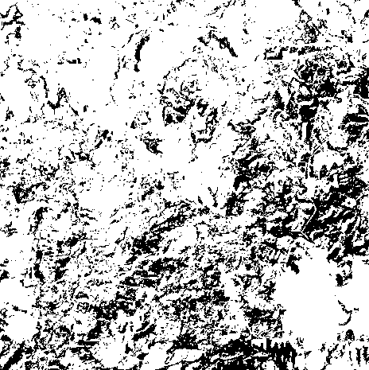

Figure 15. Trees and Streams

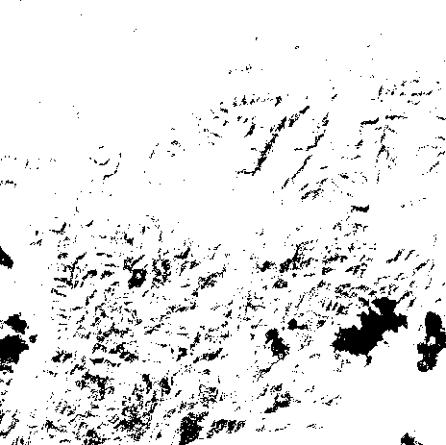
Figure 16. Shadows

Preliminary analysis was promising. Streams were found in the spectral component with trees. (Figure 15) Shadows are found around streams. (Figure 16) Streams were found well in even low-res spectral imagery. It appeared promising that SPOT MSI could be used for delineating streams.

However, it is doubtful that streams can be found in forested areas with this analysis. It is not clear that humans can find streams visually in forested areas. Streams can be found easily in analysis of terrain elevation data, provided that elevation data has adequate resolution.

It is not clear whether streams and rivers appear in extended edges. If so, they appear for the same reason as in MSI, because vegetation changes at streams. Some analysis of streams may be possible in pan imagery, e.g. 5m CIB imagery. It is much more difficult without MSI analysis; thus, it is not clear when it will be achieved.

A hierarchical MSI analysis was outlined in the proposal and statement of work. Streams appear as narrow bands that snake their way down the gradient of elevation. Since streams are detected by trees along their banks, we must discriminate trees along streams from other areas of trees. In the SOW, we described methods to analyze and discriminate narrow bands (streams and hedge rows) from broad areas (trees and orchards).

An algorithm has been implemented that extracts the local width of areas extracted in the MSI analysis. The algorithm is being debugged. Another algorithm will link together adjacent narrow pieces into curves and analyze their curvature, in conjunction with analysis of extended edges from the Binford-Chiang edge operator.

Task 4. Automated Extraction of Trees and Orchards

Automated extraction of areas including trees was outlined in task 3 above. Discriminating trees along streams from trees in forests and orchards requires algorithms described in task 3, one algorithm implemented, the other in design.

Relevant extraction of MSI features is described in Task 3 in which trees were extracted in narrow bands along rivers, streams, hedgerows and roads, and in broad areas in orchards and forests. The micro-region approach to MSI analysis was outlined. A reasonably large set of spectral classes can be extracted and discriminated. Spectral classes relate to what appear to be cartographic features.

Properties of MSI clusters associated with trees were designated manually. Tree cluster properties were analyzed as a multi-variate gaussian approximation. The cluster will be examined in more detail in the future to determine whether a non-gaussian approximation will be necessary. In addition, as the vegetation is built, tree classes will be incorporated as a mixture model. In the future, work will go toward compensating for spectral changes in illumination and in automated designation and description of MSI clusters. Both problems are fundamental and difficult.

Tree cluster descriptors were obtained as above. Similar cluster descriptors were made for other classes, vegetation in fields, human construction, clouds, and shadows.

Areas were extracted from the SPOT 20m MSI by identifying pixels that fell inside cluster boundaries. Results were about as expected; they appear promising.

Extracting curvilinear areas of trees (rivers, streams, hedgerows and roads) from broad areas of trees is described in task 3. It relies on two algorithms, one implemented and in testing, the other in design. Discrimination of classes of broad areas depends on macro and micro properties. Orchards have smooth boundaries, regular placement of trees, a single species of tree. Forests have irregular boundaries, irregular placement of trees and may have a mixture of trees. As the vegetation model is developed, we may have a useful knowledge of which species are found in orchards and their MSI cluster properties. We may also have a knowledge of which tree species are found in which mixtures in which types of forests depending on terrain, elevation, whether it has been logged, etc.

Thus, a macro extraction of orchards and forests may be made with low-res MSI from smoothness of boundaries, terrain, surrounding fields, and MSI detailed analysis. Micro discrimination based on texture and regular placement may depend on fusion of analysis of high-res pan or high-res MSI analysis.

Conclusion

It appears that road extraction in SPOT 20m MSI is reasonable for large parts of the terrain of Santiago, but not for substantial parts that are wooded and hilly. Effective linking has been accomplished over 1km x 1km subimages in the test image for one area.

MSI region extraction of cartographic features is promising for extraction of streams, based on a novel micro-region analysis. Streams have been extracted effectively in MSI analysis. An algorithm to discriminate streams geometrically from other areas extracted with streams has been implemented and is in testing.

The same MSI analysis has extracted areas including trees. Algorithms for separating orchards and forest will be developed. MSI analysis has the potential for more detail than initially expected.

